Classification of current procedure codes

**Current procedure code Range  Description**  
00100-01999 Anesthesia  
  
00021-69990 Surgery-General  
  
10040-19499 Surgery-Integumentary System  
  
20000-29999 Surgery-Musculoskeletal System  
  
30000-32999 Surgery-Respiratory System  
  
33010-37799 Surgery-Cardiovascular System  
  
38100-38999 Surgery-Hemic and Lymphatic System  
  
39000-39599 Surgery-Mediastinum and Diaphragm  
  
40490-49999 Surgery-Digestive system  
  
50010-53899 Surgery-Urinary System  
  
54000-55899 Surgery-Male Genital System  
  
55970-55980 Surgery-Intersex  
  
56405-58999 Surgery-Female Genital System  
  
59000-59899 Surgery-Maternity care and Delivery  
  
60000-60699 Surgery-Endocrine System  
  
61000-64999 Surgery-Nervous System  
  
65091-68899 Surgery-Eye and Ocular Adnexa  
  
69000-69979 Surgery-Auditory System  
  
69990-69990 Surgery-Operating Microscope  
  
70010-79999 Radiology  
  
80048-89356 Pathology and Laboratory  
  
90281-99199 Medicine – Part 1  
  
99500-99602 Medicine – Part 2  
  
99201-99499 Evaluation and Management  
  
A0021-A0999 Transportation Services Including Ambulance  
  
A4206-A7527 Medical and Surgical Supplies  
  
A9150-A9999 Administrative, Miscellaneous & Investigational  
  
E0100-E8002 Durable Medical Equipment  
  
G0008-G9130 Procedures/Professional services  
  
J0120-J8999 Drugs Administered Other than Oral method  
  
J9000-J9999 Chemotherapy Drugs

q- Miscellaneous Services

p- pathology related

v-vision, speech ,hearing

c- Temporary Codes for Use with Outpatient Prospective Payment System

l- Orthotic and Prosthetic Procedures, Devices

r-radiology

D-oral heath assessment

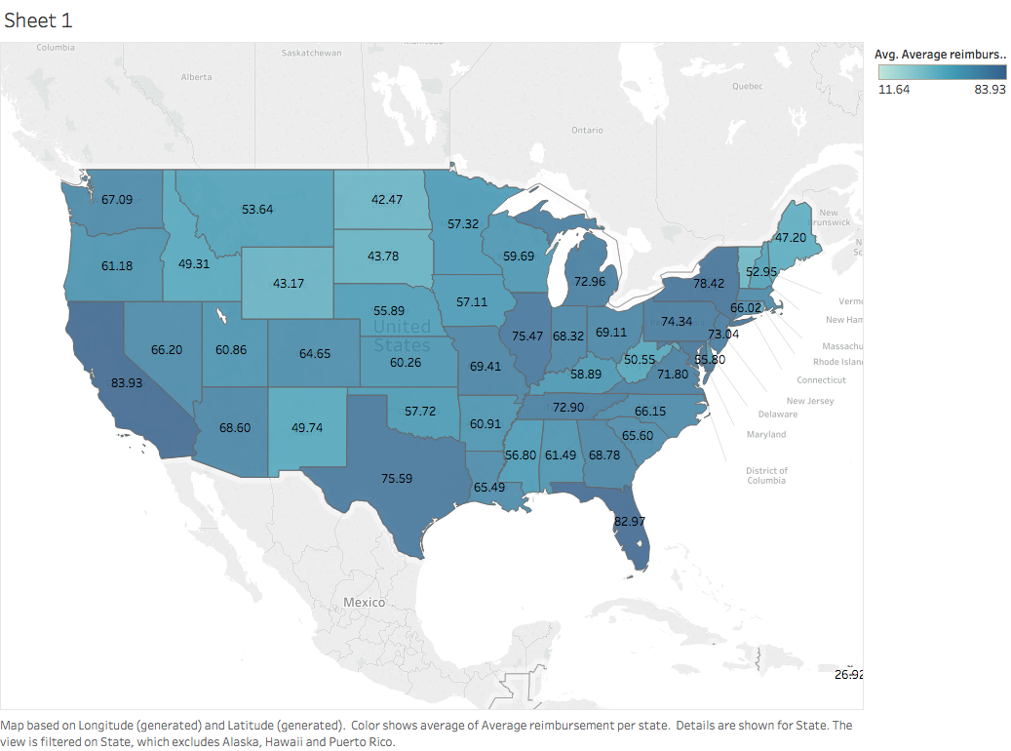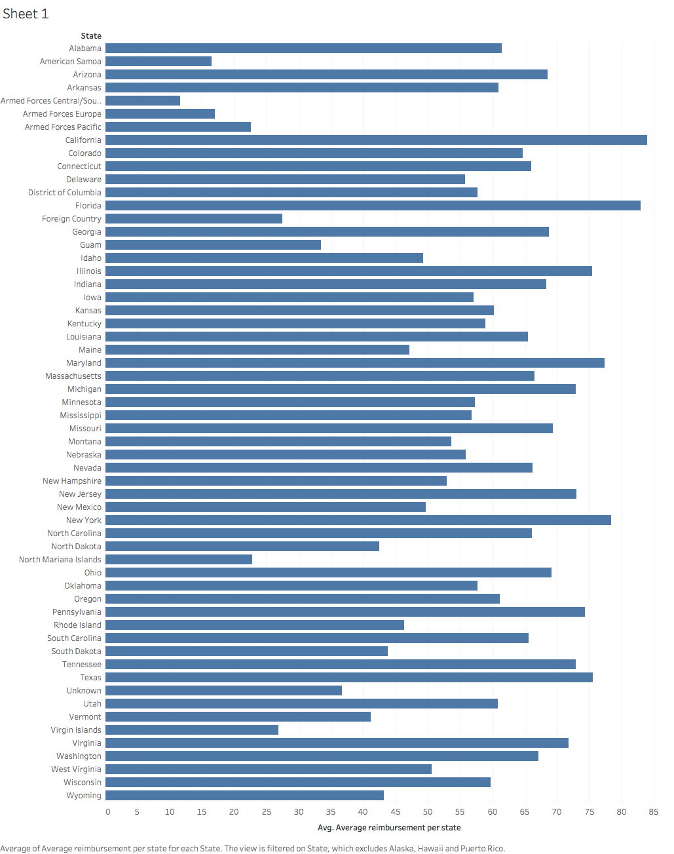

California, Florida, New York, Texas are the top 4 states where the average reimbursement difference is high.

The difference is calculated between the Avg. medicare allowed amount vs. the Avg. medicare payment amount.

So, a low difference means that there is a probability that the medicare will cover a good portion of the submitted claim in that particular state.

A high difference means that there is a good gap between the submitted claim and payment amount by the medicare.

The above four states have a very high gap.

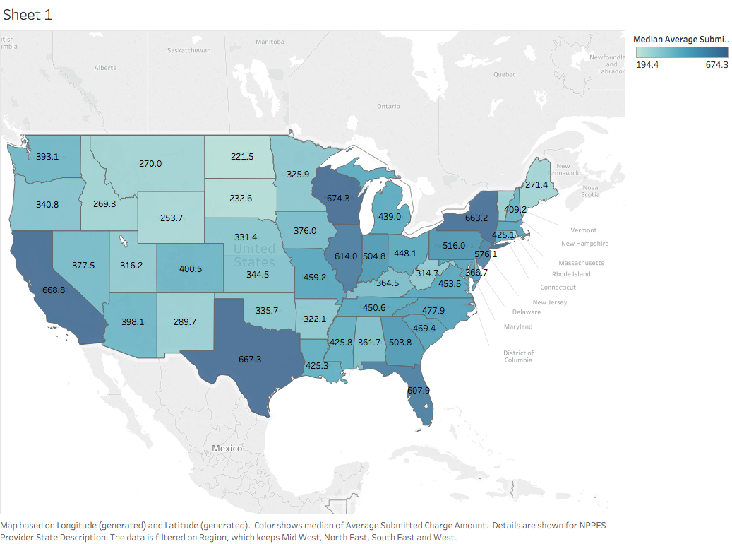

The above graph represents the Median medicare submitted amount per state.

The high values are in the states of Wisconsin, California, Texas, New York.

The median values for the submitted medicare amount is very high for Michigan, and still the gap between the submitted claim and payment amount by the medicare is small.

The reason the gap is high for California, Texas , New York can be because of the high average submitted claim in those particular states.

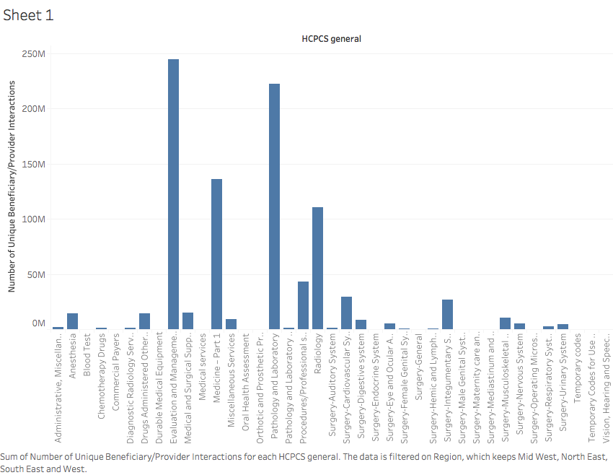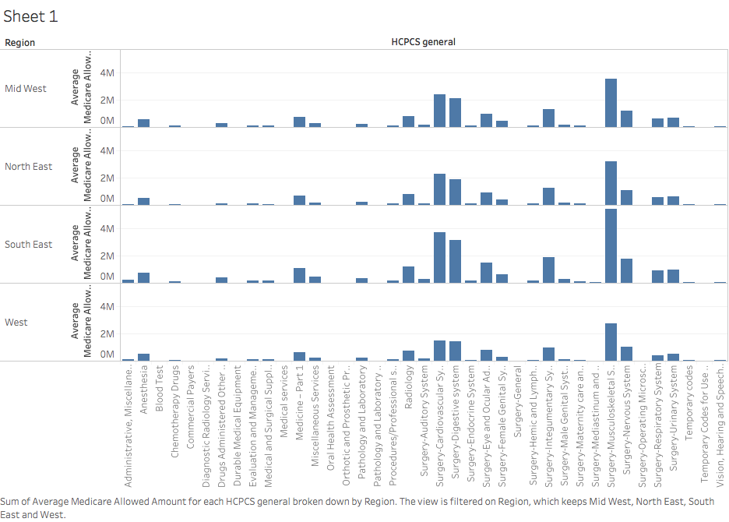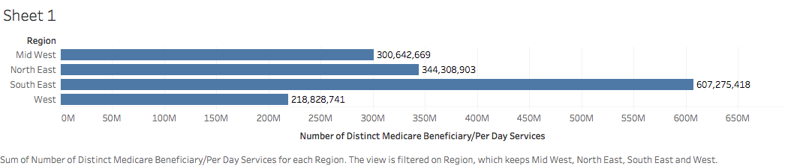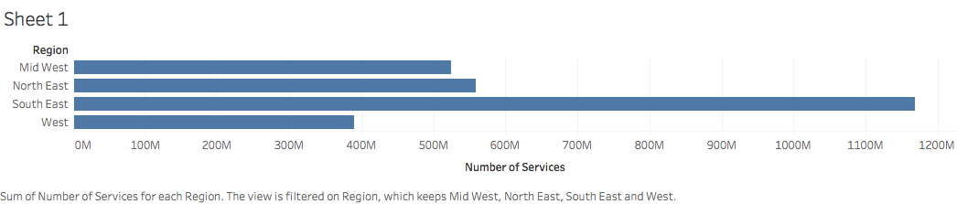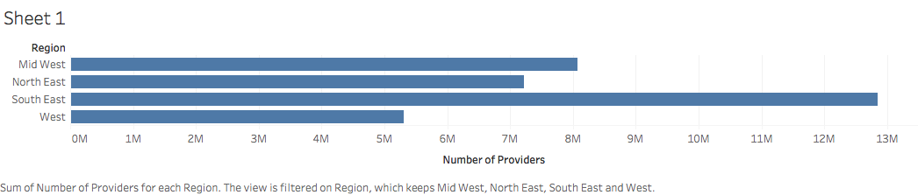

Find the average ..not sum for the above three graphs and paste them below.

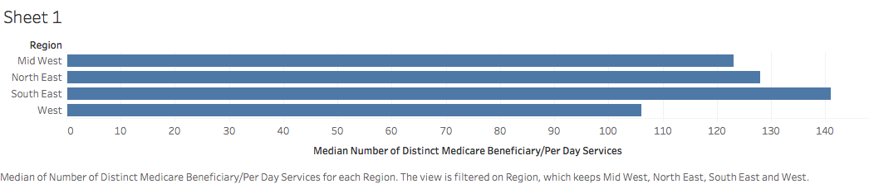

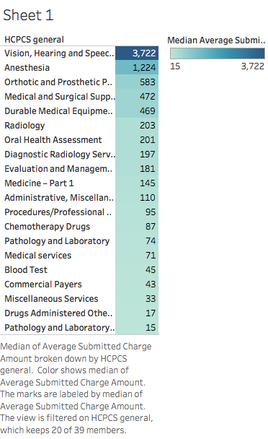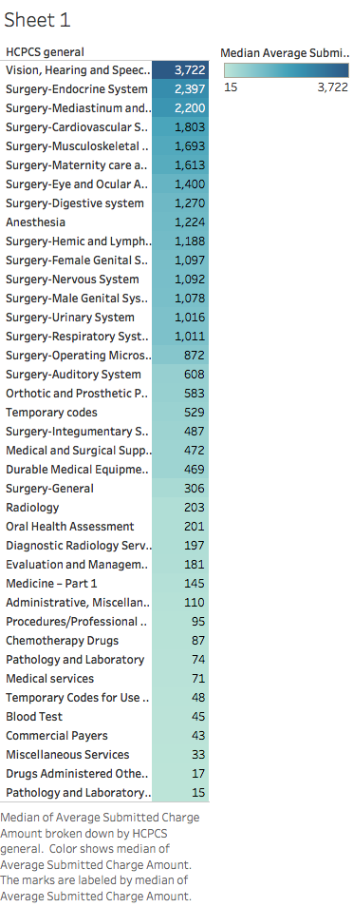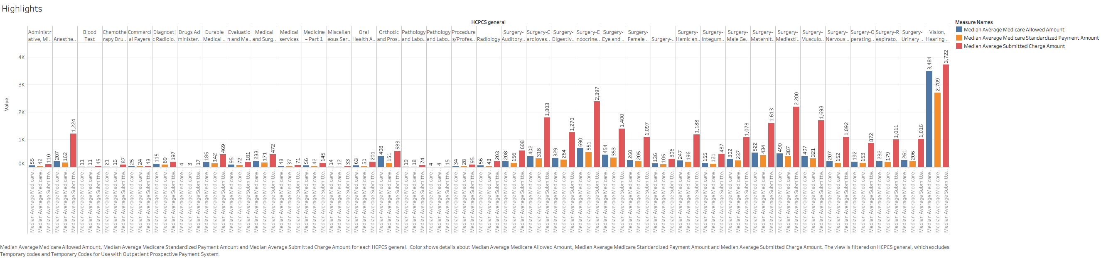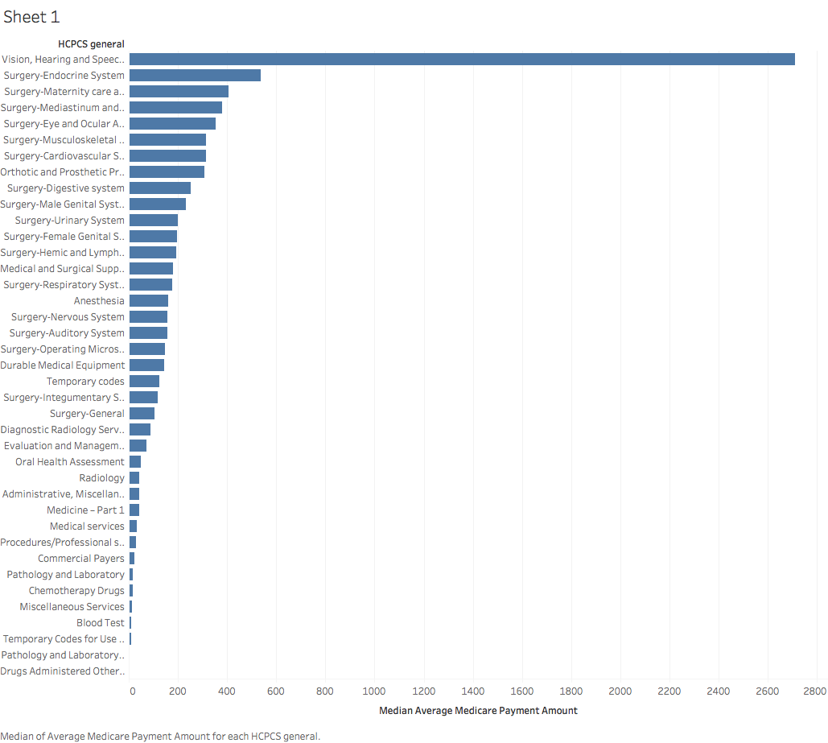

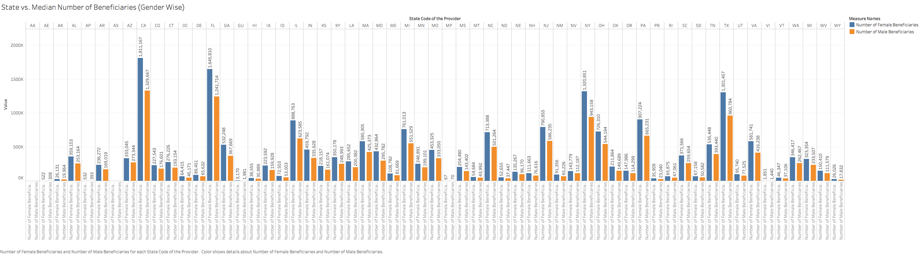

DATA CONSOLIDATION AND SORTING

For provider file

Firstname, last name , middle initial removed.

City, street address, zip code removed.

Drug suppress indicator and medical suppress indicator removed.

Region added

For HCPCS file:

Removed out of US records,

Region Added

Summary stats for different types of amounts, only USA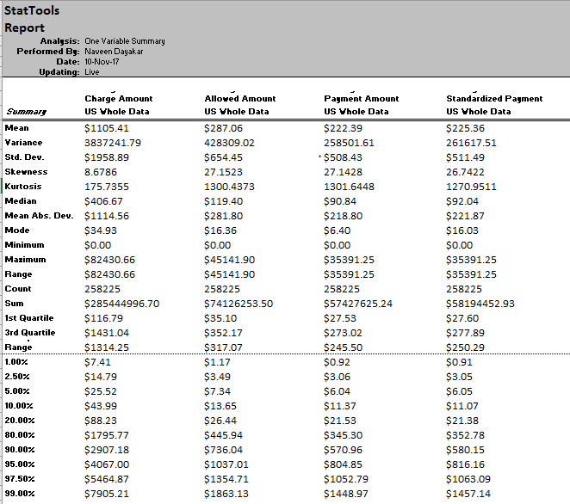

-

Summary stats for average reimbursement per state

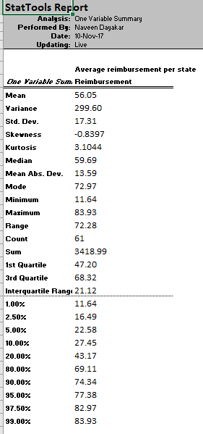

Analysis on Only individual providers from NE

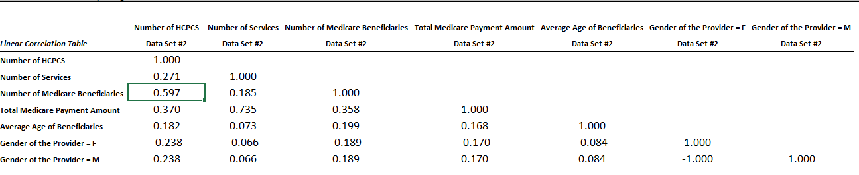

The Number of HCPCS vs Number of Medicare Beneficiaries have high correlation.

The highest correlation is between Number of Services and Total Medicare Payment Amount.

There is no correlation between the gender of the provider and the average age of beneficiaries.

Very less correlation between Number of services vs Number of Medicare Beneficiaries

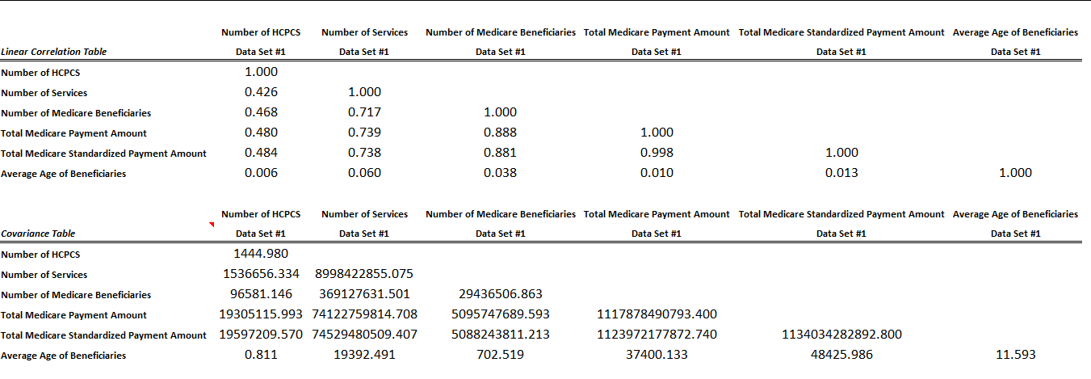

High correlation between Number of services and

1)Number of medicare beneficiaries

2)Total medicare payment amount

3)Total Medicare Standardized payment amount

Very high correlation between Number of medicare beneficiaries and

1)Total medicare payment amount

2)Total Medicare Standardized payment amount

So, the number of services provided has a high correlation to the number of medicare beneficiaries,

Which in turn results in high medicare payment and standardized payments.

For the individuals, the number of services did not influence the number of medicare beneficiaries by any chance.

This is for I only SE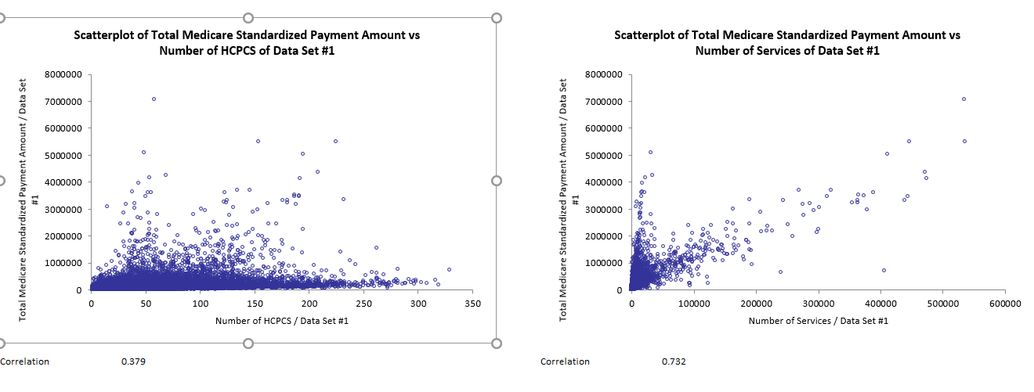

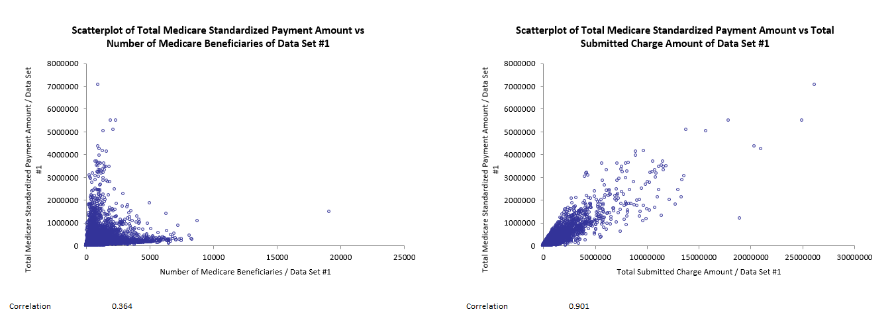

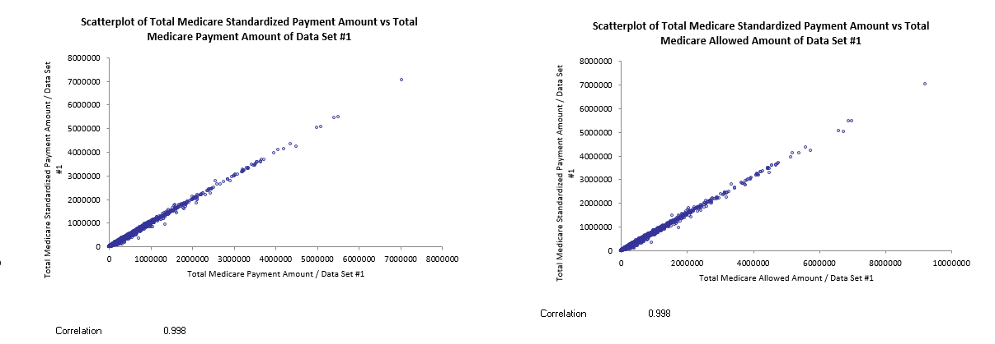

O providers only SE

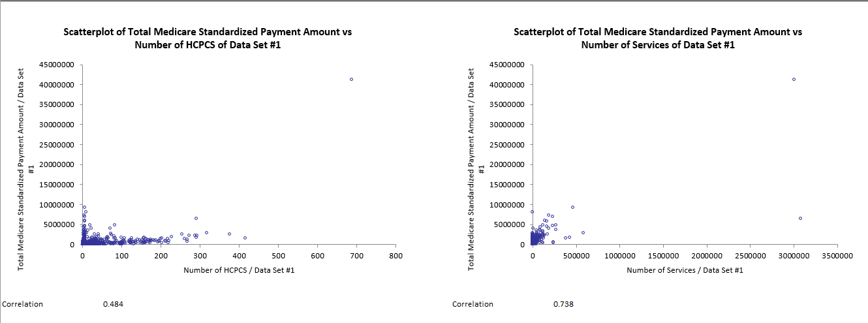

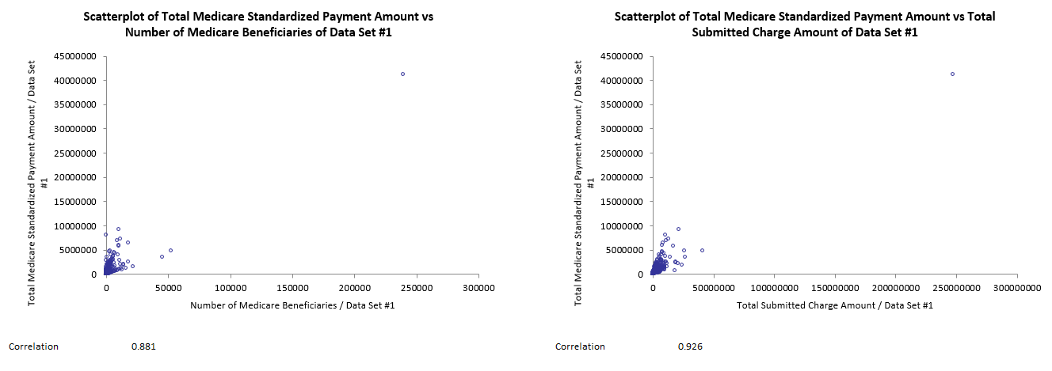

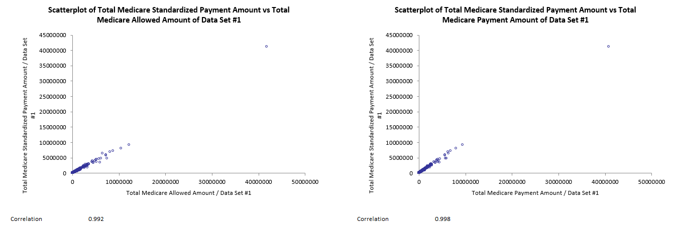

All SE providers, confidence interval

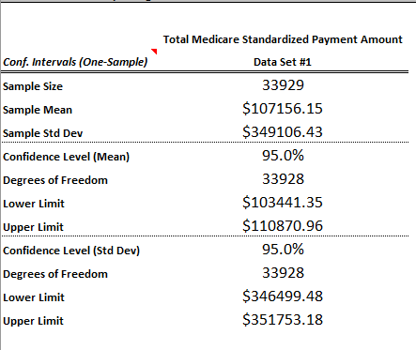

All SE O providers,

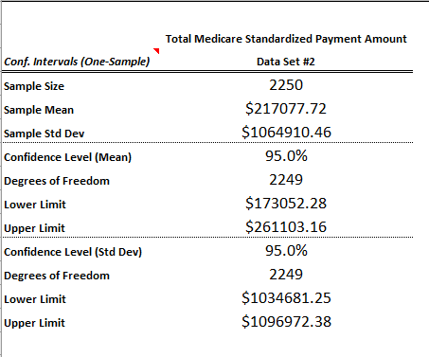

All SE individual providers

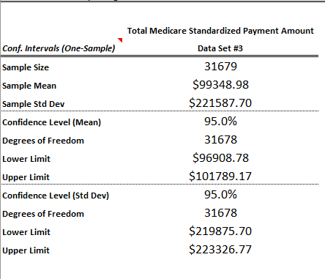

Multiple regression (Only Individual providers-SE region)

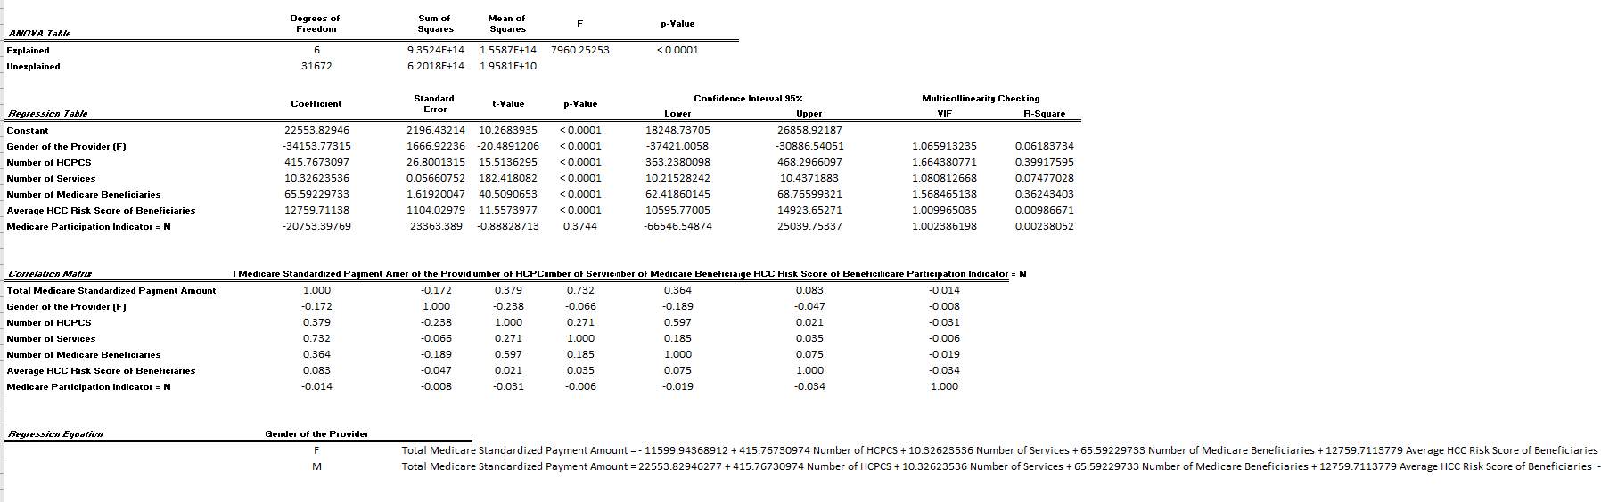

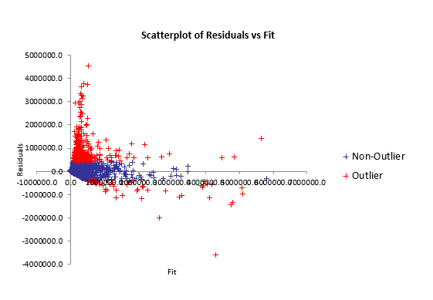

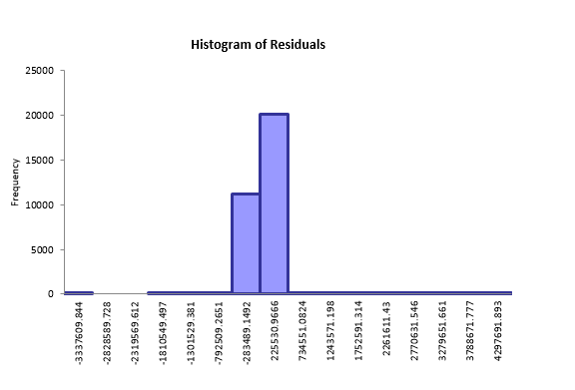

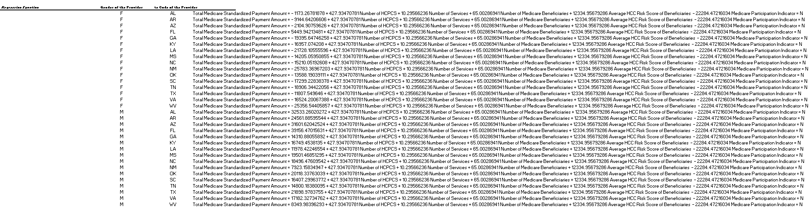

(insert graph of florida having highest repayment using tableau here)

Only O providers SE region

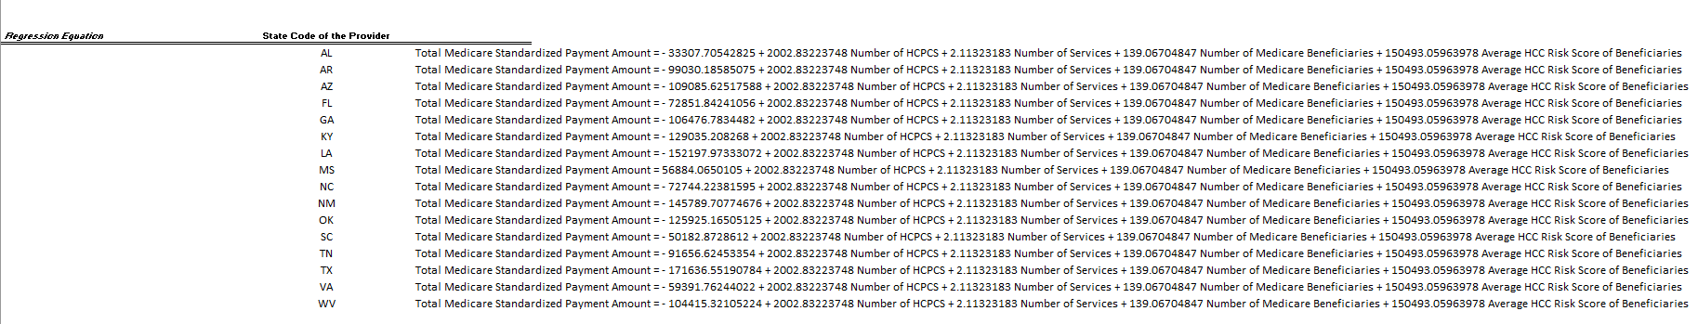

MS has high intercept by default. For organization suppliers.

